- Deploy your your previous assignment flask frontend and express backend in kubernetes cluster locally with minikube.
Answer:- To deploy the assignment Flask frontend and Express backend in a Kubernetes cluster locally, the steps are as follows:-
  - For Frontend:-
    - First, I’ll create a Frontend folder, and in it I’ll create a templates folder and in that create an index.html file. With a basic look, I’ll add “Hello World” text and some environment variables.
    - Then create an app.py and a requirements.txt file outside the templates folder.
    - And after that, I’ll write a Docker file.
- For Backend:-
- First, I’ll create a Backend folder, and in it I’ll create three files: app.py for my application, the second one is connection.py for setting up the connection between backend & mongodb, and the third file will be requirements.txt, which has flask, pymongo and dnspython in it.
- And after that, I’ll write a Docker file.
- Now, I will verify that the frontend and backend are working perfectly !!!
- Alright, everything is working fine, so I’ll now use Mongo-Express to view the MongoDB on my browser, which is on “localhost:27017”.
- As everything is working now, I will build Docker images for the frontend and backend by the names “hero-frontend” and “hero-backend”.
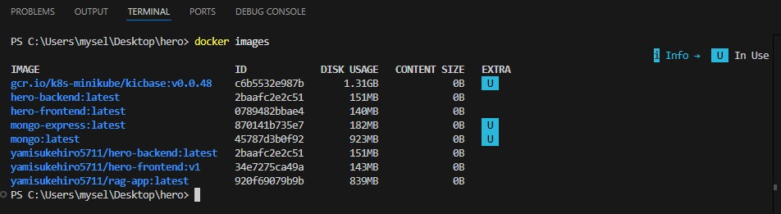
- Now I’ll compose a stack by the name of “hero” which has frontend, backend, mongo and mongo-express images in that container.
- After that, I’ll create a file called “k8s”, which is a Kubernetes file where I’ll write YAML files for frontend, backend, mongo, and mongo-express.
- The YAML files are as follows:-
    - Backend.yaml:-
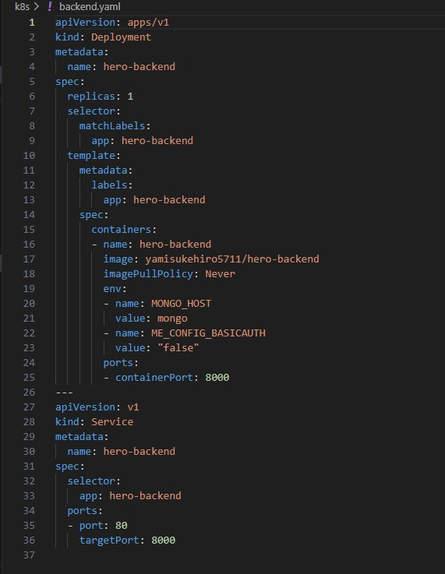
    - Frontend.yaml:-
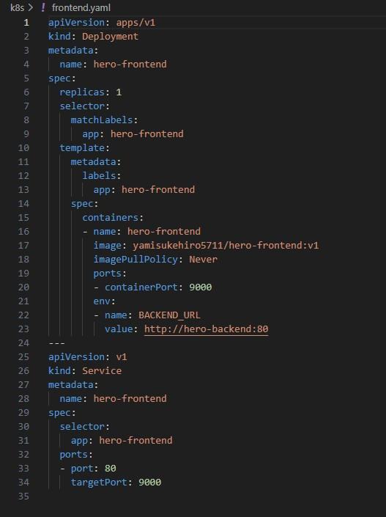

    - Mongo-express.yaml:-
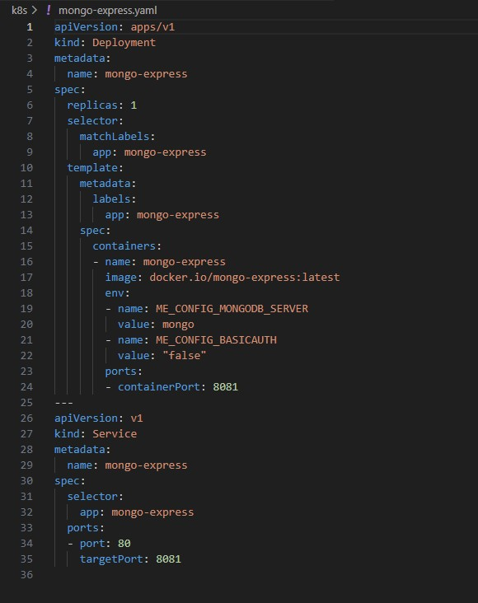

    - Mongo.yaml
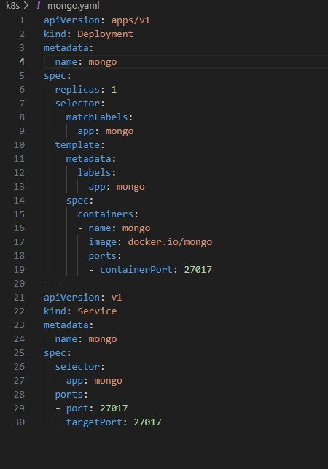

- Now I will start minikube with the command “ minikube start”
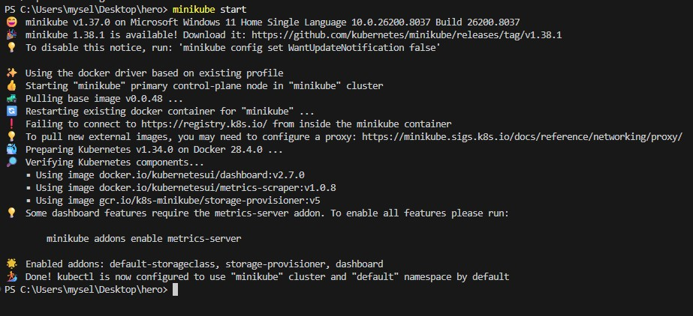
- After this, I’ll run the command “kubectl apply -f k8s/”, this command will do is it will build through the YAML files which I have created in the k8s folder by running the services in it and create the pods according to it.
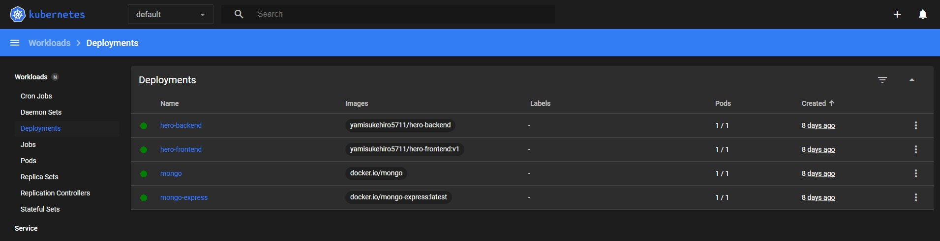

- Now I’ll forward ports by using the commands “kubectl port-forward svc/hero-frontend 9000:80” for frontend, “kubectl port-forward svc/hero-backend 8000:80” for backend, and “kubectl port-forward svc/mongo-express 7000:80” for mongo-express.
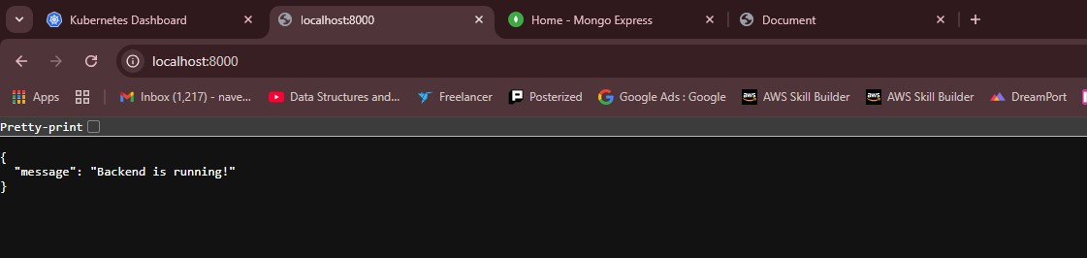
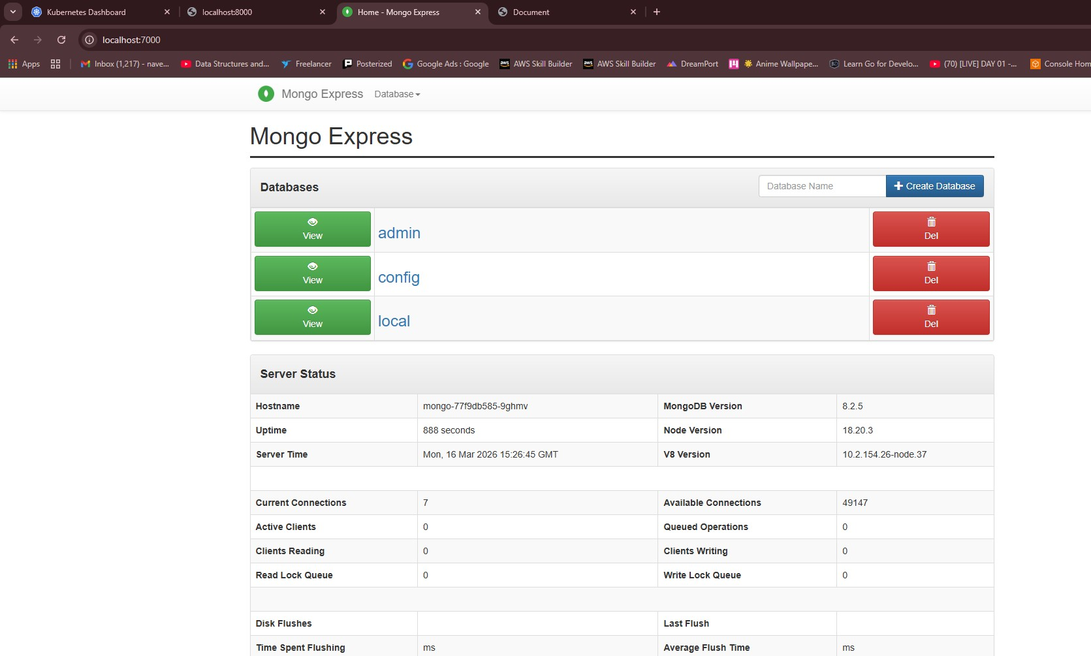
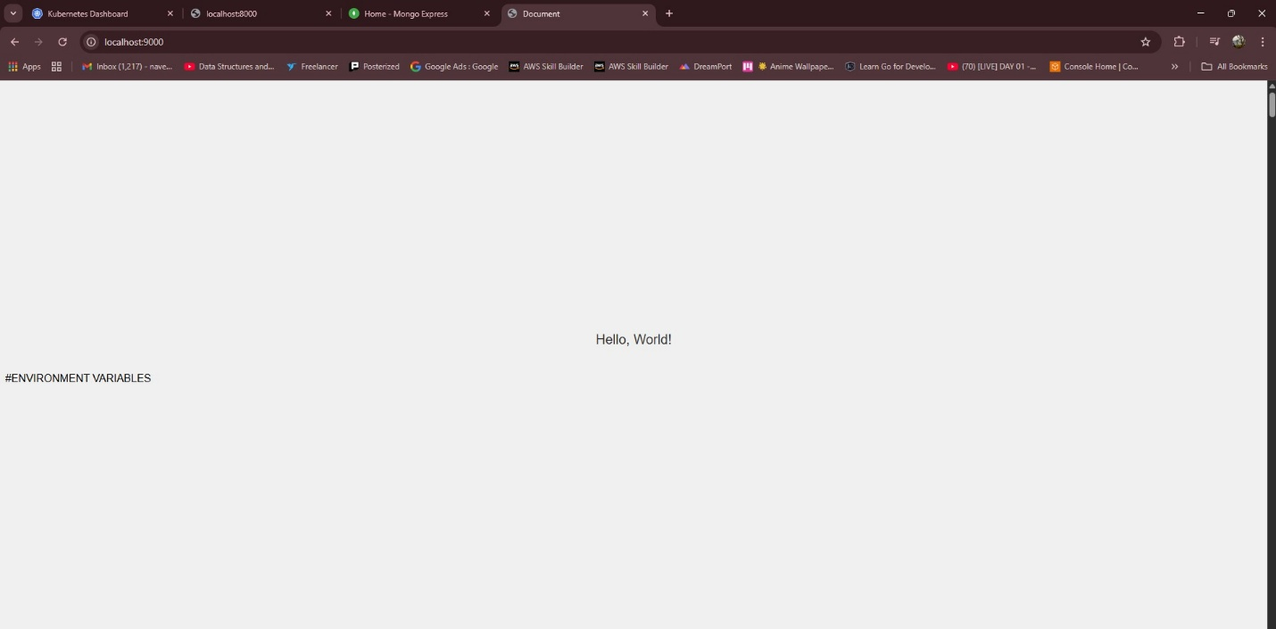
- As the pods are, it’s time to experiment by feeding the data in my backend and see it on the frontend page and Mongo Express.
- First, lets check if its have any data prefilled or not. As it does not have any data.
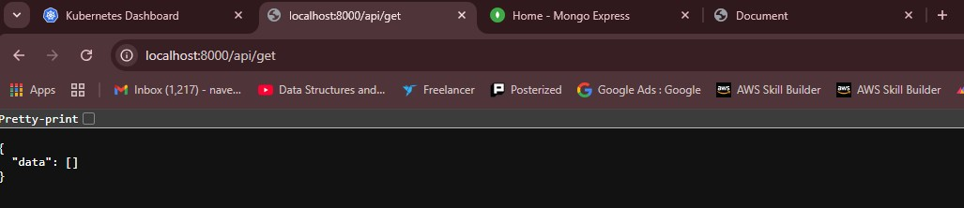
- Lets add some data in the backend by the help of the command in the search bar “localhost:8000/api/add/ritesh roshan” and check it again with the command “localhost:8000/api/get”.
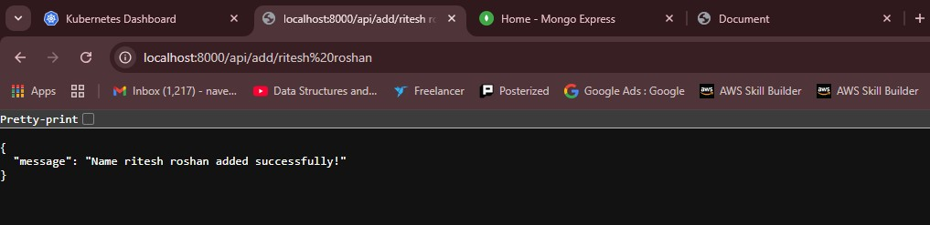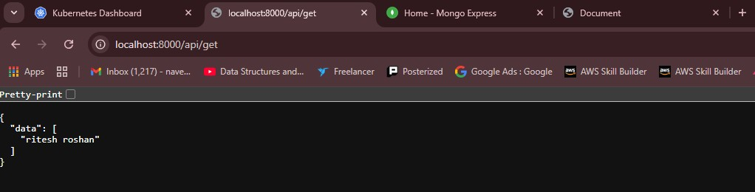
- Now lets add more data in the backend and I’m gonna verify it on the frontend and mongo-express also.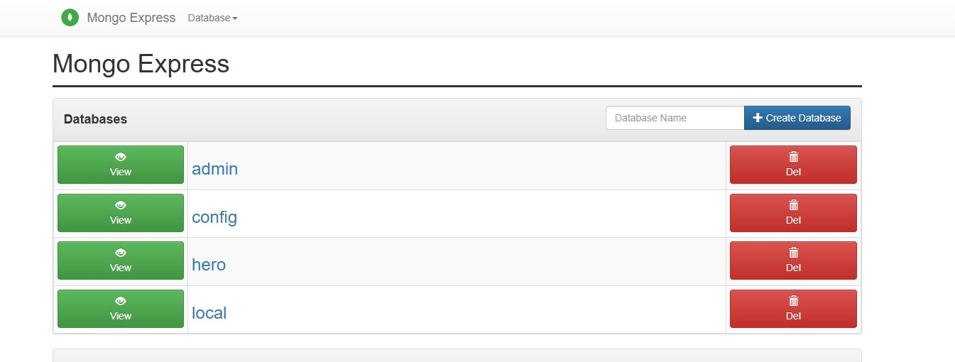
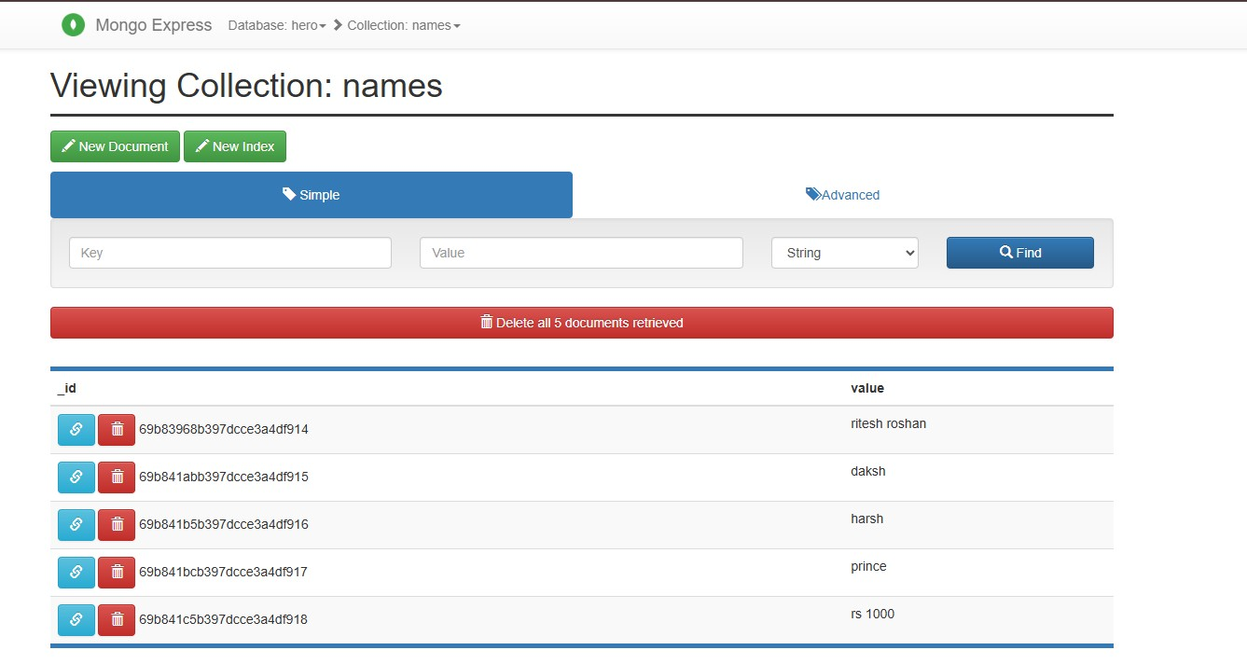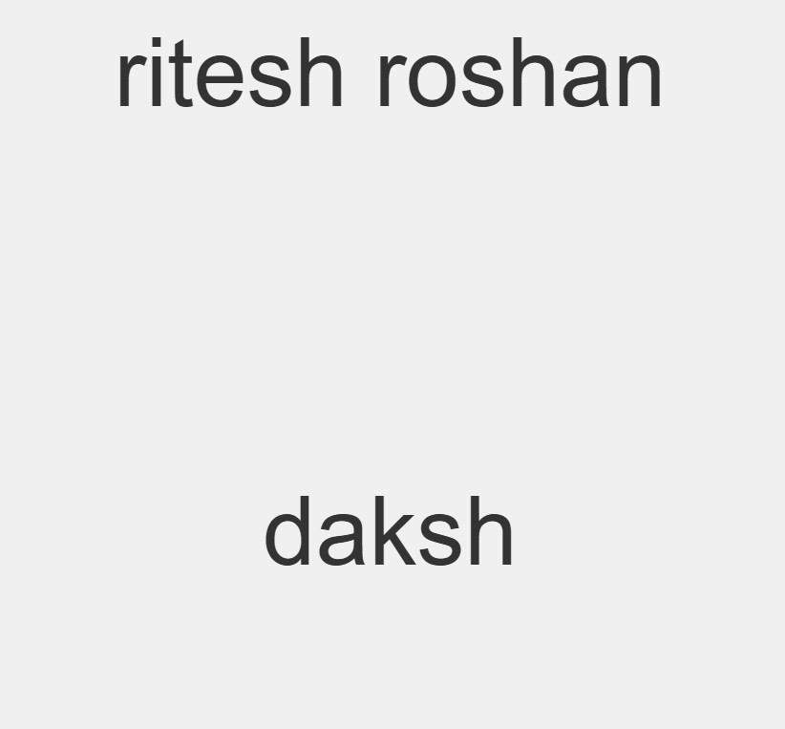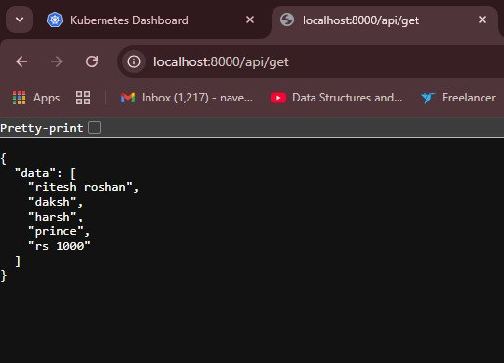
- As all the services and pods are working perfectly, the ports are interlinked between frontend, backend and MongoDB, where the data is fetched from the backend and can be visible in the frontend and the mongo-express pages.
Submission guidelines: share github repo link and screenshots of your running deployments and commands.

